Declaration of Conformity (DoC)

We, Shenzhen Doke Electronic Co., LTD
801, Building3, 7th Industrial Zone, Yulv Community, Yutang Road, Guangming District, Shenzhen, China

Declare that the DoC is issued under our sole responsibility and belongs to the following product(s):

Product Type: | 4G Smart phone
Trademark： | Blackview
Model Number(s): | WAVE 10
Operating system:
Hardware Version:J567F_9230SMB_D4UFU_V1.0

Software Version :WAVE10_EEA_J567F_V1.0_A16

(Name of product, type or model, batch or serial number)

System components:，

PIFA Antenna:
Bluetooth: 1.9dBi
2.4G WLAN: 1.9dBi
5G WLAN: 2.1dBi
GSM 900: -3.0 dBi; GSM 1800: 1.7 dBi
WCDMA B1: 2.1 dBi; WCDMA B8: -2.9 dBi
LTE B1: 2.0 dBi; LTE B3: 1.5 dBi; LTE B7: 1.9 dBi; LTE B8: -2.8 dBi; LTE B20: -3.6 dBi
GPS: 0dBi;

Adapter:
Model: QZ-01004EA00
Input: 100-240V~50/60Hz 0.3A
Output: 5.0V 2.0A(10.0W)
Manufacturer: Guangdong Quanzhi Technology Co.,Ltd.

Rechargeable Li-ion Battery:
Model: FHPV466495PNJ; Specification: DC 3.85V, 5000mAh
Manufacturer: Shenzhen Nuojia Technology lndustrial Co.,LTD
USB Cable: 100cm;

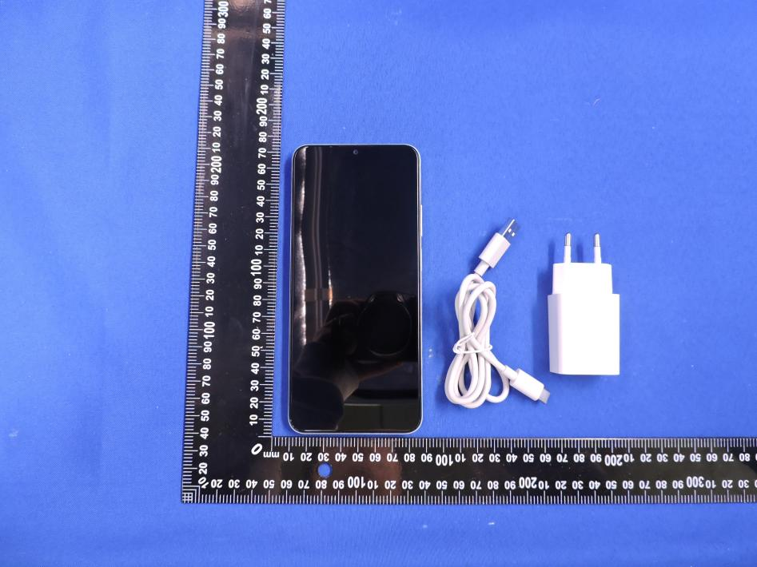

The object of the declaration described above is in conformity with the essential requirements of the relevant Union harmonization legislation: Radio Equipment Directive RED (2014/53/EU).
The following harmonized standards and technical specifications have been applied:

HEALTH & SAFETY (Art. 3(1)(a)):

EN 50360:2017+A1:2023 EN 50566:2017+A1:2023 EN IEC/IEEE 62209-1528:2021 EN 50663:2017 EN 62479:2010
EN IEC 62368-1:2020+A11:2020
EMC (Art. 3(1)(b)):

ETSI EN 301 489-1 V2.2.3 (2019-11)

ETSI EN 301 489-3 V2.3.2 (2023-01)

ETSI EN 301 489-17 V3.3.1 (2024-09)

ETSI EN 301 489-19 V2.2.1 (2022-09)

ETSI EN 301 489-52 V1.3.1 (2024-11)

EN 55032:2015+A11:2020; EN 55035:2017+A11:2020

EN IEC 61000-3-2:2019+A2:2024; EN 61000-3-3:2013+A2:2021+AC:2022

Radio Spectrum (Article 3.2):

ETSI EN 301 511 V12.5.1 (2017-03);

TS 151 010-1 V13.14.0 (2024-06)

ETSI EN 301 908-1 V15.2.1 (2023-01)

ETSI EN 301 908-2 V13.1.1 (2020-06)

ETSI EN 301 908-13 V13.3.1 (2024-10)

EN 300 328 V2.2.2 (2019-07);

EN 303 345-1 V1.1.1 (2019-06)

EN 303 345-3 V1.1.1 (2021-06)

EN 301 893 V2.1.1 (2017-05);

EN 300 440 V2.2.1 (2018-07);

EN 303 413 V1.2.1 (2021-04);

The submitted samples of the above equipment has been tested and found to comply with the following European Directives:
RoHS Directive 2011/65/EU & (EU) 2015/863

Notified Body Involved:

Notified Body Name: DERYCOM CERTIFICATION SERVICES, INC.
Notified Body Number: 3052
Notified Body Assessment Performed: Module B/C on Article 3.1a, 3.1b, 3.2 EU-type examination certificate number: JEC-62

RF Specification:

Function | Operation Frequency | Max RF output power:
BLE | 2402MHz–2480MHz | 3.72dBm
BT(BR+EDR) | 2402MHz–2480MHz | 4.32 dBm
WIFI 2.4G  802.11b/n(20MHz):  802.11n(40MHz): | 802.11b/n(20MHz):2412-2472MHz  802.11n(40MHz):2422~2462MHz | 14.10dBm
Wi-Fi 5.2G  802.11a/n/ac (20MHz):  802.11n/ac(40MHz):  802.11ac(80MHz): | 802.11a/n/ac (20MHz):5180~5240MHZ  802.11n/ac(40MHz):5190~5230MHZ  802.11ac(80MHz):5210MHz | 13.69dBm
Wi-Fi 5.8G  802.11a/n/ac (20MHz):  802.11n/ac(40MHz):  802.11ac (80MHz): | 802.11a/n/ac(20MHz):5745~5825MHz  802.11n /ac(40MHz):5755~5795MHz  802.11ac (80MHz):5775MHz | 13.49 dBm
GSM/GPRS/EGPRS 900 | TX(Uplink):880M‐915MHZ;  RX(Downlink):925M‐960MHZ | 31.59dBm
GSM/GPRS/EGPRS 1800 | TX(Uplink):1710M‐1785MHZ;  RX(Downlink):1805M‐1880MHZ | 29.35dBm
WCDMA B1 | TX(Uplink):1920-1980MHz;  RX(Downlink):2110-2170MHz | 21.67 dBm
WCDMA B8 | TX(Uplink): 880-915MHz;  RX(Downlink):925-960MHz | 21.91dBm
LTE FDD B1 | TX(Uplink):1920-1980MHz;  RX(Downlink):2110-2170MHz | 22.75 dBm
LTE FDD B3 | TX(Uplink) :1710-1785MHz;  RX(Downlink):1805-1880MHz | 22.63 dBm
LTE FDD B7 | TX(Uplink) :2500-2570MHz;  RX(Downlink):2620-2690MHz | 23.93 dBm
LTE FDD B8 | TX(Uplink): 880MHz to 915 MHz  RX(Downlink): 925 MHz to 960 MHz | 22.64dBm
LTE FDD B20 | TX(Uplink): 832MHz~862MHz;  RX(Downlink):791MHz~821MHz | 23.40 dBm
GPS | Rx(Downlink): 1.57542GHz | --
FM | Rx(Downlink): 87.5-108MHZ | --

Tests for SAR are conducted using standard operating positions with the device transmitting at its

highest certified power level in all tested frequency bands. The maximum SAR values tested on this device when used in its normal position at the ear and when used closet othe body(at a minimum distance of 5mm/0mm) are:

Max SAR Value(W/kg)  Limitis 2.0(W/kg) for10-g | 10g-Head | 0.838W/kg
Limitis 4.0(W/kg) for10-g | 10g-Body/MemberDAS | 1.152W/kg

Technical file held by: Shenzhen Doke Electronic Co., LTD

801, Building3, 7th Industrial Zone, Yulv Community, Yutang Road, Guangming District, Shenzhen, China

Signed for and on behalf of: Shenzhen Doke Electronic Co., LTD

Name and Title: | Duan chunlin/Manager
Address: | 801, Building3, 7th Industrial Zone, Yulv Community, Yutang Road, Guangming District, Shenzhen, China



Signature of Authorized Person
2026-01-06

